ASEND WEBSITE UI DESIGN

This document provides specifications of ASEND website UI design.

Colors Used: White, black and royal blue.

PAGES (Desktop)

The website will have 4 pages namely: home (the landing page), about, services, and concours.

1. Home Page: The home page is the landing page i.e. the page which first loads or opens up when the link is clicked (e.g. <https://asendprep.com>). This page will contain a summary of everything about ASEND: who we are, what we offer, what we have been doing, and how you can contact us. As shown in the figure below. The various sections include: navigation menu, a simple hero section with a background image of the whole team, a simple summary about us and what we do, with a picture of us in prep class or orientation, our partners (e.g. chitechma, mountain university etc.), summary of services we offer (orientation, one on one mentorship, prep class, pre-med & pre-engr exams, and a see more buttons which will take us to the services page), statistics page(number of students who have succeeded through us, number of team members etc.), our team (this section gives a brief insight on our staffs, their qualification or school level, links to their social media and what they teach, a simple call to action to join the team which takes users to Google form to be filled, testimonial section(students testimony of how ASEND helped them make it to their dream school), our recent activities (which includes world engineering day, prep class, premed/pre-engr exams and so on), students answers to frequent questions we get from students during orientation), a contact form and finally a footer.

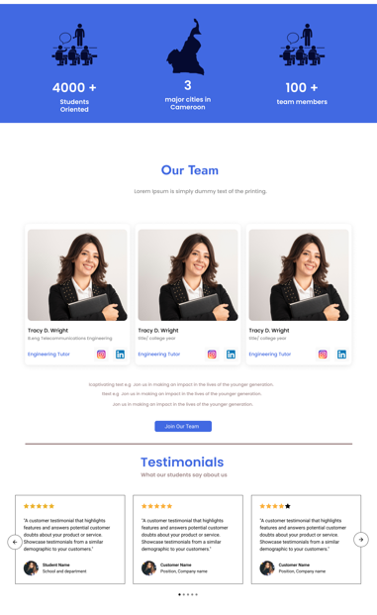

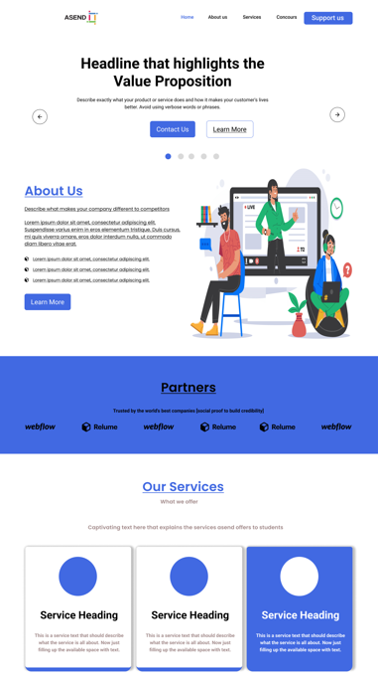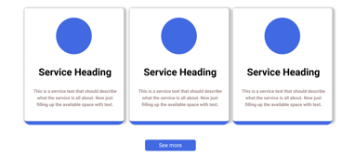

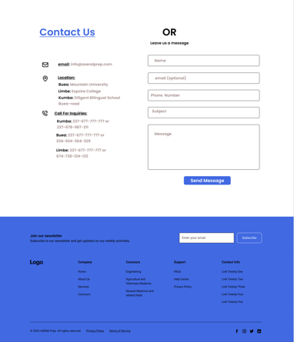

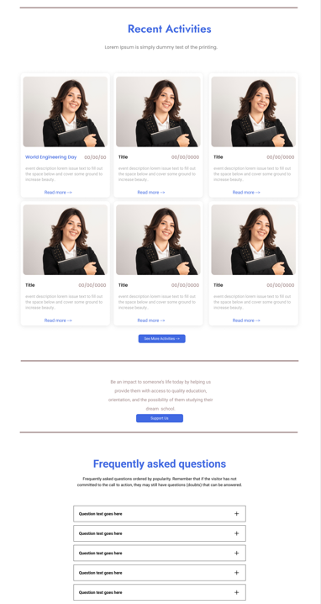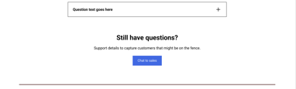

1. About US: This page gives a brief intro to ASEND, its mission, how it started, founders and team members. It is separated into the various sections: header(a picture of the team), our mission, about(i.e. who ASEND is, when ASEND started, how they started, and how far they have gone), our leaders(consisting of founders and 3 exco members), our team(consisting of few staffs), contact info and footer.



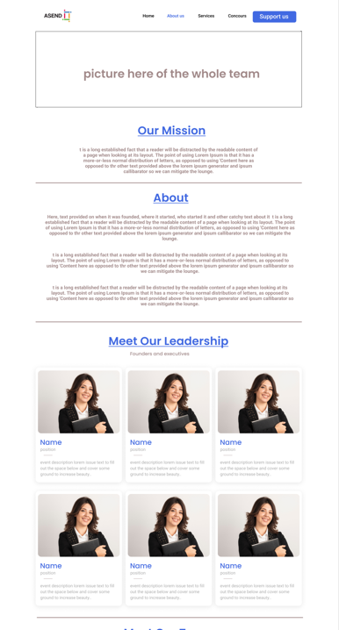

1. Services Page: This page is a summary of the services we offer. It is divided into 4 sections, the header (a picture of us during orientation and a catchy phrase), our services, contact form and footer. The services are sub-divided into 3 namely

* Services offered before concour such as online classes, orientation, prep class etc.
* Services after concour (mentorship etc.)
* IT services e.g (concour registration, computer maintenance, graphic design, web development, data analysis etc)





1. Concours Page: This page will contain the various concour and some info about them, e.g requirements, degree obtained, departments etc. This will be divided into medicine, engineering and agriculture and veterinary medicine. Each concour section is such that when a button is clicked, the details about that concour are shown.





PAGES (Mobile)

Mobile Menu:

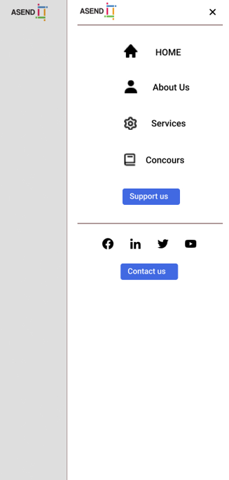

Concours Page:







